# THE TABLEAU HR SCORECARD:MEASURING SUCCESS IN TALENT MANAGEMENT

**1.INTRODUCTION**

* 1. **Overview:**

**The HR scorecard is a strategic HR measurement system that helps to measure ,manage,and improve the strategic role of the HR department.The HR scorecard is meant to measure leading HR indicators of business performance.**

**Leading indicators measurements that predict future business growth.The HR scorecard is a tool that helps measure,manage and improve the role of the HR function within an organization.**

**1.2 Purpose:**

**The HR scorecard is a management tool which allows a business to :**

**1.Manage HR as a strategic asset and a source of competitive advantage.**

**2.Quantitatively demonstrate HR’s contribution to the firm’s financial results and bottom line profitability.**

**An HR scorecard allows HR personal to individually align their goals across the department and organization.**

**2.PROBLEM DEFINITION & DESIGN THINKING**

**2.1 Empathy Map**

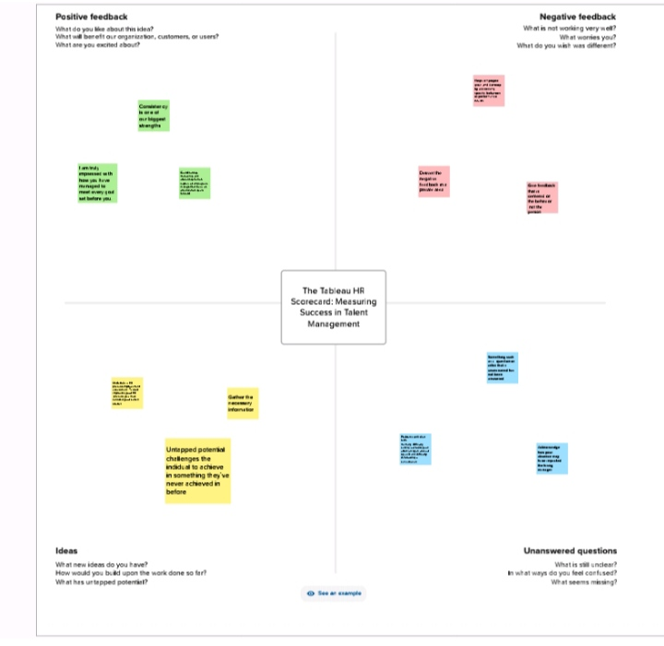

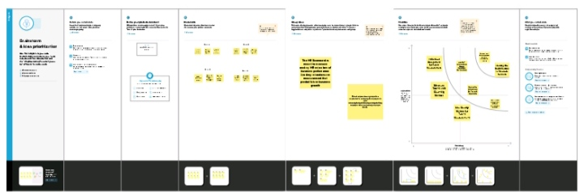

### RESULT

**Dashboard**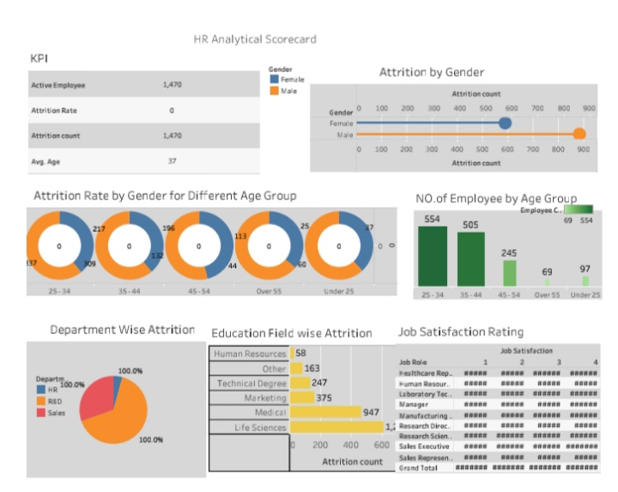

**Story**

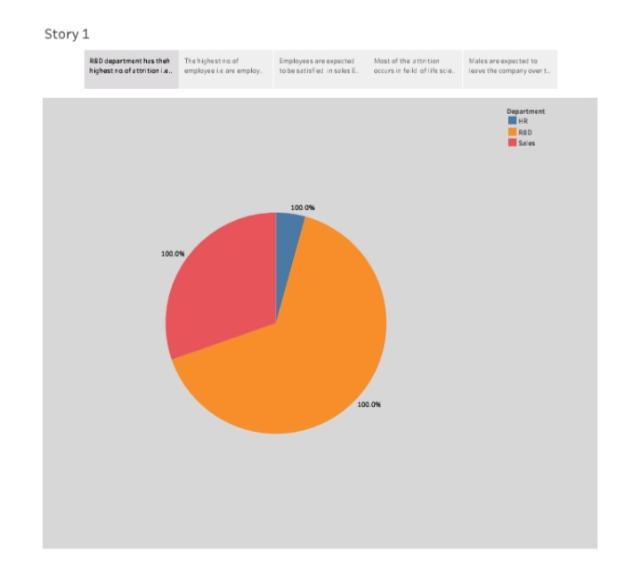

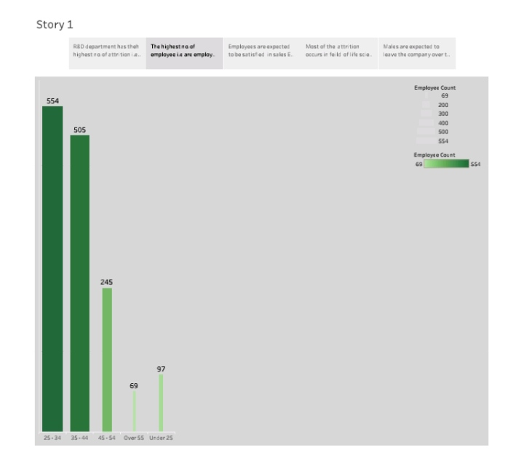

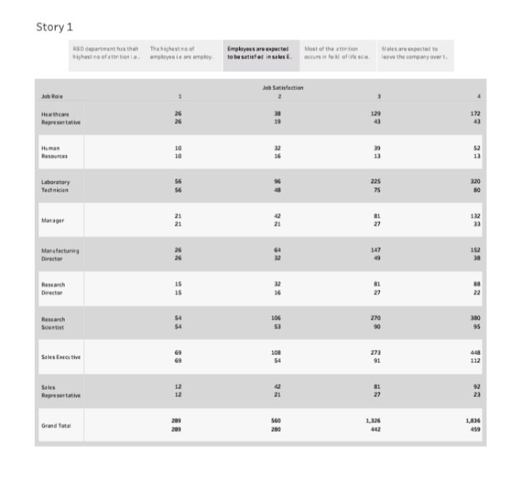 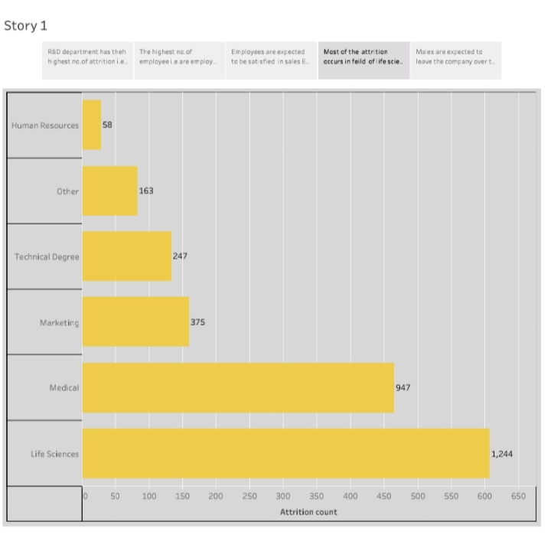

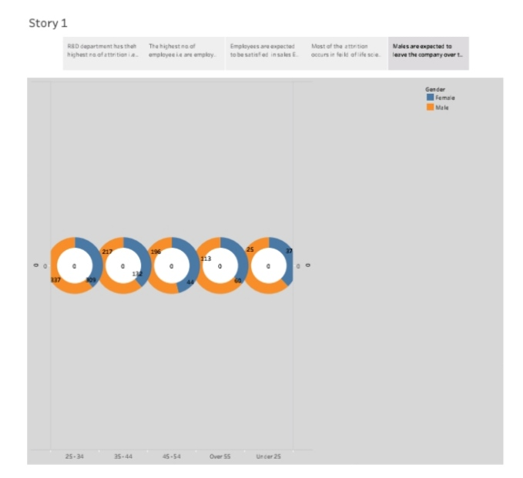

**ADVANTAGES**

* **Break strategy into things you can measure.**
* **See a balanced view of your organization.**
* **Improve strategic communication.**
* **Visualize strategic cause and effect.**
* **Improve organizational alignment.**
* **Support desition-making**

**DISADVANTAGES**

* **It can’t be copied precisely from example.**
* **It requires strong leadership support to be successful.**
* **It can be difficult to keep everyone one the same page.**
* **It may appear too rigid for the way you manage.**

**APPLICATIONS**

* **Companies have a number of options available to help identify and resolve issues with their internal processes.**
* **Balanced scorecards allow companies to collect and study data from four key areas,including learning and growth,bussines processes, customers,and finance.**

**CONCLUSION**

**The benefits of the HR scorecard are having better strategic planning, it improve strategy communication and execution, better alignment of projects & initiatives. More insightful management information, focused performance reporting, improved organizational alignment and improved process alignment.**

**FUTURE SCOPE**

**HR scorecard designed to assist HR leaders in responding quickly to change and making future plan scope, HR functions. HR departments will have to understand better how technology is changing to embrance the changing industry standards.**